Day in the Life of the Hudson River 10/14/21
East River 62nd Street
RIVER MILE: 6
Salt Front: ~ 49
Manhattan International High School- Ms. Athena Theodoris
65 students & 6 adults
Latitude: 40.760503 Longitude: -73.956649
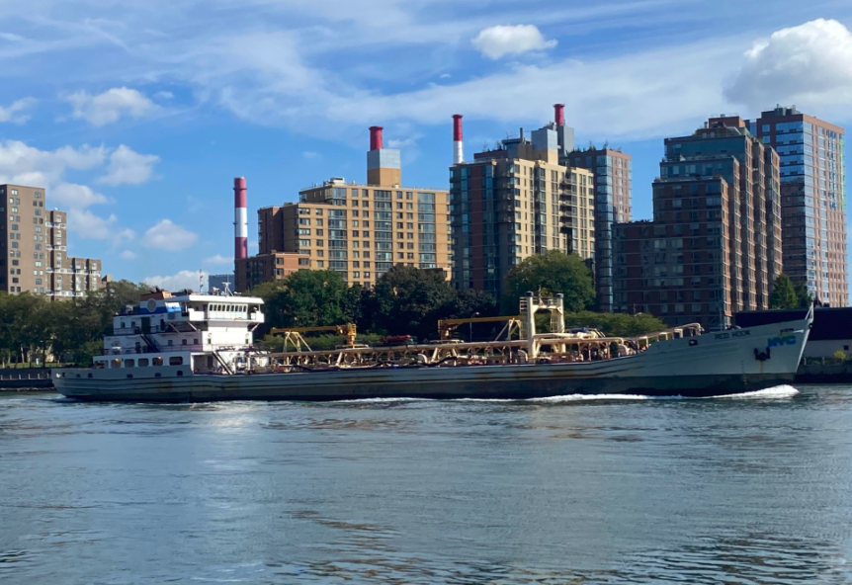
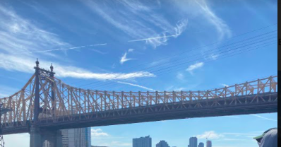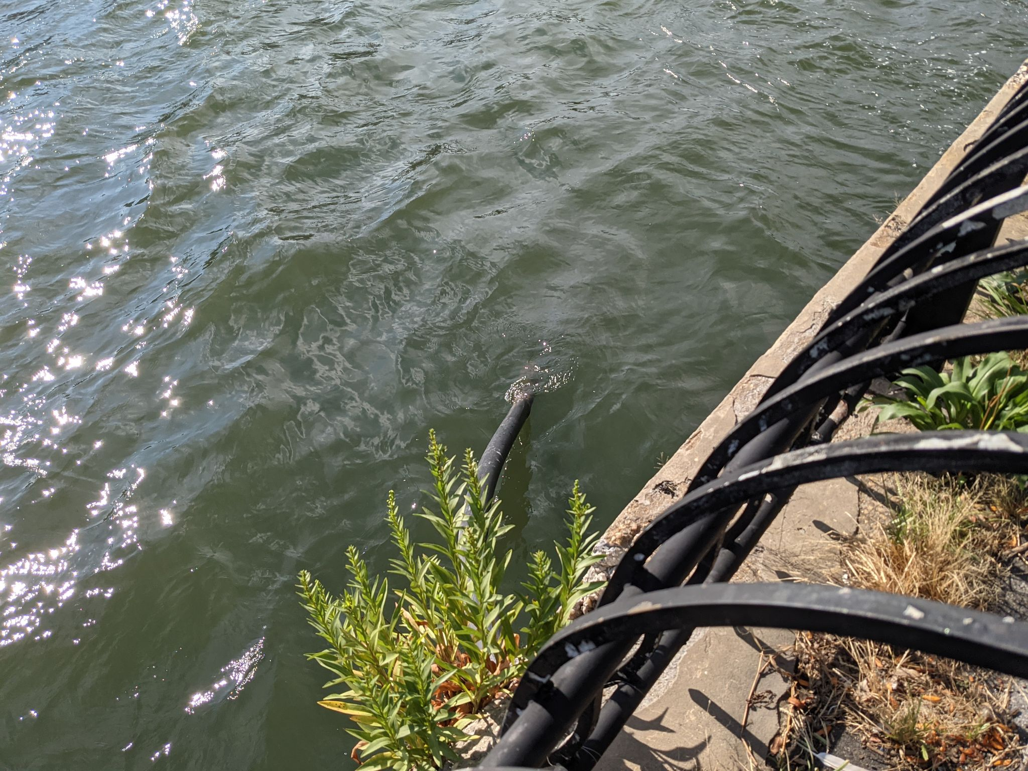
Above: Boat traffic on the East River, Queensborough Bridge, Black pipe entering the waterway

Location: East River by (Andrew Howell park) on FDR N around 62nd street, across Roosevelt Island
Area: East River at John Finley Walk near Andrew Haswell Park on FDR N around 62nd street, across Roosevelt Island.
Surrounding Land Use: 80% Commercial, 20% Urban/Residential with trees and little plants around
Sampling Site: Rocky ground along with pier, grassy forested and parking lot
Water: calm
River Bottom: 700 cm depth muddy bottom
*NR = Not read/recorded
ITEM |  | Time |  | Reading |  |  |  | Comments
Physical
Air Temperature |  | 10:40-11:40 AM |  | Average 21.4º C |  |  | Average 70.4 º F
Wind Speed: |  | 11:15 AM-1:15 PM |  | Anemometer  Average 1.92 mph |  |  | Beaufort  NR | Direction  NR
Weather today |  | 10:57 AM |  | 26-50% cloud cover |  |  | No rain
Weather the past 3 days: |  | Mostly cloudy, windy, and sunny
Tides- |  | Time |  | Rising, Falling, Unchanged |  |  | Height (cm)
*Tides were read very close together so no change evident
Current- |  | Time |  | Cm/sec |  | Knots | North/South | Ebb/Flood/Slack
*One of several measures |  | 12:15 PM |  | 16.3 |  | 0.317 | NR | NR
Water Temperature- digital thermometer |  | 11:30 AM-1:00 PM |  | 24.7º C average |  |  | 74.48 º F
Turbidity- Long Sight Tube |  | 11:45 AM-12:30 PM |  | 113 cm
Chemical
Salinity- hydrometer |  | 11:45 AM-12:15 PM |  | 26.4 ppt average
Standardized Salinity- refractometer |  | 11:05 AM |  | 25 ppt
DO – Chemets |  | Time |  | Temp |  |  | ppm DO | % Saturation
*results were from 4 ppm to 8 ppm so very widespread. Color kits can be hard to read |  | 11:45 AM-12:45 PM |  | 23.6 º C |  |  | 6.4 average | 74.4%
pH – test strips |  | 11:45 AM-12:45 PM |  | 4.6 average |  |  |  | *test stripes unreliable in the field
Nitrates- NR
Phosphates- NR
Biological
Fish - |  | Number |  | Name |  |  | Length of longest | Length of smallest
*Oyster cage
Fish Totals |  | TOTAL: 0 |  | Diversity: 0
Macroinvertebrates |  | Number |  | Name |  |  | Length of longest | Length of smallest
 |  | 1 |  | Blue Crab |  |  | NR | NR
Macroinvertebrate Totals |  | TOTAL: 1 |  | Diversity: 1
Sediment Core -NR
Length | H2S smell |  | Oxid Top |  | Oil |  | Grain Size | Other Features
Unable to do at this site
Boats-NR
 | Time |  | Name |  | Color |  | North/Southbound | Light/Loaded
Commercial | 11:12 AM |  | Gm11105 |  | Black |  | North | Light
 | 11:21 AM |  | NYC Ferry |  | White & Green |  | South | N/A
 | 11:11 AM |  | Never Enuff |  | Black |  | South | Loaded
 | 11:31 AM |  | Ferry |  | Blue |  | South | N/A
 | 11:18 AM |  | Cargo |  | White & Black |  | North | Loaded
Recreational | 11:31 AM |  | Nat Pack 4 |  | White |  | South
 | 11:29 AM |  | Raxe G25 |  | White & Blue |  | South
 | 11:32 AM |  | Speed Boat |  | White |  | South

